

ASSIGNMENT

LANKA

COMP40053

**Software Development – HTML**

**COM2523**

|  |  |  |
| --- | --- | --- |
| **Assessment Type and Weight** | **Hand In** | **Hand Out** |
| Individual Assignment (60%) | 28th July 2025 | 22th Sep 2025 |

Name – Weerasinghe Hashini Vihanga De Silva

Student ID – CB015618

Contents

1. Introduction 4

2. Planning & Design 4

2.1 Wireframes 4

1.Home Page 4

2.Recipe Page 5

3.Calculator page 6

4.Workouts Page 7

5.Mindfulness Page 9

6.Contact Page 10

3. Testing & Debugging 12

The testing makes sure that the website is functional, accessible, and usable. Bugs are fixed in debugging in the light of the validation and performance tests. 12

3.1 CSS Validation (W3C CSS Validator) 12

3.2 HTML Validation (W3C Validator) 12

1.Index.html 13

2.Recepies.html 13

3.Calculator.html 13

4.Bodyparts.html 14

5.Equipment.html 14

6.Mindfulness.html 14

7.Contact.html 15

The above screenshots demonstrate that all HTML codes were fully debugged, and validation confirmed that no errors remain. 15

3.3 Accessibility Testing (WAVE Tool) 15

3.4 Lighthouse Testing (Chrome DevTools) 16

The above screenshots illustrate how Lighthouse testing was conducted across different screen sizes and different pages to ensure responsiveness and performance 17

3.5 Test Case Table 17

3.6 Responsiveness Testing 19

3.6.1 Mobile Responsive 20

3.6.2 Desktop Responsive 23

3.6.3 Tablet Responsive 26

4. Hosting & Deployment 30

5. Conclusion 31

# 1. Introduction

This report describes the designing, developing, testing, and launching of the GreenBite Wellness site which was developed as part of Assignment 3. The project aim was to develop and test a fully functional, responsive, and interactive multi-page web site with HTML, CSS, and JavaScript based on the current guidelines and practices in web development.

GreenBite site advises on healthy lifestyle by featuring recipes, exercises, meditation aids, calorie counter, and wellness suggestions. The report describes the planning and design of the project, the implementation of user interface and interactions, validation of HTML and CSS, the accessibility testing provided by WAVE, optimization of performance by Lighthouse, and testing of responsiveness on desktop and mobile platforms. The latter deployment was done with the help of GitHub Pages.

# 2. Planning & Design

## 2.1 Wireframes

Wireframes are graphical displays of the composition of every webpage. They give a roadmap of the location where the components of the navigation, contents and the media will be located.

### 1.Home Page

The Home page shows the introduction design, navigation menus, highlight areas, and a welcome area to the users.

### 2.Recipe Page

The Recipe page shows the organization of recipes, including pictures, descriptions, and instructions of food preparation.

### 3.Calculator page

This page represents the design of the nutritional calculator with input fields, buttons, and output sections.

### 4.Workouts Page

This page demonstrates how the exercises are grouped and displayed to the users, with interactive features.

#### Body Page

#### Equipment Page

### 5.Mindfulness Page

This page shows the design of mindfulness sessions, such as guided meditation and multimedia.

### 6.Contact Page

The contact page gives the form of the contact form, leaves of feedback, and necessary details of communication.

# 3. Testing & Debugging

# The testing makes sure that the website is functional, accessible, and usable. Bugs are fixed in debugging in the light of the validation and performance tests.

## 3.1 CSS Validation (W3C CSS Validator)

My CSS code was checked on W3C CSS Validator to make sure that it is correct according to CSS standards and appropriate styling rules.

## 3.2 HTML Validation (W3C Validator)

The syntax and structure error of the webpage were tested with every page of the web site with the help of the W3C HTML Validator.

### 1.Index.html

### 2.Recepies.html

### 3.Calculator.html

### 4.Bodyparts.html

### 5.Equipment.html

### 6.Mindfulness.html

### 7.Contact.html

## The above screenshots demonstrate that all HTML codes were fully debugged, and validation confirmed that no errors remain.

## 3.3 Accessibility Testing (WAVE Tool)

The accessibility issues of the site were checked with the help of WAVE to make sure that the site corresponds to the accessibility requirements and could be operated by people with disabilities.

## 3.4 Lighthouse Testing (Chrome DevTools)

Lighthouse was used to test performance, access, best practices, and SEO. The problematic cases were identified and debugged to score better.

## The above screenshots illustrate how Lighthouse testing was conducted across different screen sizes and different pages to ensure responsiveness and performance

## 3.5 Test Case Table

|  |  |  |  |  |  |  |
| --- | --- | --- | --- | --- | --- | --- |
| **Test ID** | **Description** | **Pre-Condition** | **Test Steps** | **Expected Result** | **Actual Result** | **Status** |
| TC-01 | Verify navigation links work | Website loaded | Click each nav link (Home, Recipes, Calculator, Workouts, Mindfulness, Contact) | User is redirected to correct section/page | As expected, | Pass |
| TC-02 | Verify logo redirects to home | Website loaded | Click on GreenBite logo | Redirects to homepage | As expected | Pass |
| TC-03 | Verify Recipes filter | Recipes page open | Select a category from dropdown | Recipe list updates with filtered items | As expected | Pass |
| TC-04 | Verify Nutrition Calculator input | Calculator page open | Enter valid height, weight, and age values, then click Calculate | Results (micronutrients breakdown) are displayed with colored lines | As expected | Pass |
| TC-05 | Verify empty Nutrition Calculator input | Calculator page open | Leave fields blank and click Calculate | Validation prevents empty submission / shows error | As expected | Pass |
| TC-06 | Verify Workout Generator button | Workouts page open | Select equipment/body part and click "Generate Workout" | Exercises are generated and displayed | As expected | Pass |
| TC-07 | Verify Timer functionality | Mindfulness page open | Click Start/Stop timer | Timer starts and stops correctly | As expected | Pass |
| TC-08 | Verify breathing animation text | Mindfulness page open | Wait during session | Text alternates between “Inhale…” and “Exhale…” every 4 seconds | As expected | Pass |
| TC-09 | Verify Contact form submission | Contact page open | Fill in Name, Email, Message and click Submit | Form submits successfully (or validation shown if fields empty) | As expected | Pass |
| TC-10 | Verify responsive layout | Open on mobile screen | Resize browser to < 768px width | Layout adjusts (grid becomes single column, nav collapses) | As expected | Pass |
| TC-11 | Verify images load | Any page | Load site with images enabled | All images (recipes, workouts, mindfulness, icons) load | As expected | Pass |
| TC-12 | Verify alt text for accessibility | Disable images in browser | Inspect img tags | Alt texts are displayed for each image | As expected | Pass |
| TC-13 | Verify favicon/icon loads | Website loaded | Check browser tab | Website icon is displayed | As expected | Pass |
| TC-14 | Verify hamburger menu toggle | Mobile view | Click hamburger icon | Navigation menu opens/closes correctly | As expected | Pass |
| TC-15 | Verify no broken links | Website loaded | Click all internal links | No 404 errors, all links valid | As expected | Pass |

## 3.6 Responsiveness Testing

The site has been tested on various devices to ascertain that it has appropriate layout and usability.

### 3.6.1 Mobile Responsive

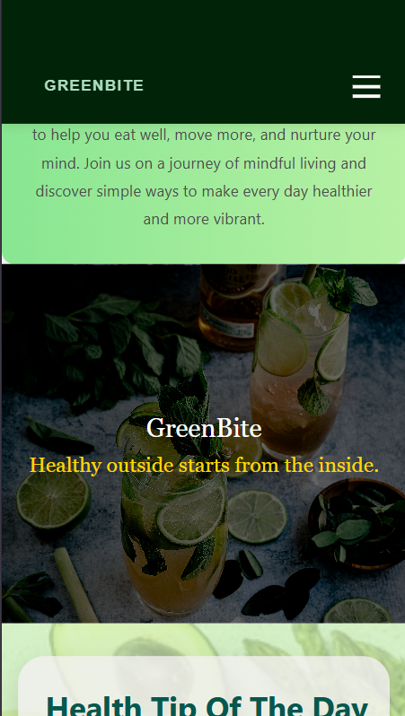1.Home page

#### A screenshot of a phone AI-generated content may be incorrect.2.Recipie Page

#### 3.Calculator Page

#### 4.Workouts Page

##### A screenshot of a cell phone AI-generated content may be incorrect.Body Page

##### Equipment Page

#### 5.Mindfulness Page

#### 6.Contact Page

### 3.6.2 Desktop Responsive

The desktop variant of the user interface has been taken as screenshots to show that the screens are well-aligned and accessible.

#### 1.Home Page

#### A screenshot of a menu AI-generated content may be incorrect.2.Recipie Page

#### 3.Calculator Page

#### 4.Workouts Page

##### Body Page

##### A screenshot of a computer AI-generated content may be incorrect.Equipment Page

#### 5.Mindfulness Page

#### 6.Contact Page

### 3.6.3 Tablet Responsive

#### 1.Home Page

#### A screenshot of a recipe AI-generated content may be incorrect.2.Recipe Page

#### A screenshot of a calorie calculator AI-generated content may be incorrect.3.Calculator page

#### 4.Bodyparts Page

#### 5.Equipment Page

#### 6.Mindfulness Page

#### A screenshot of a contact us AI-generated content may be incorrect.7.Contact page

# 4. Hosting & Deployment

The GreenBite website was deployed using GitHub Pages. The deployment process involved uploading all validated and debugged files to GitHub, ensuring the site is publicly accessible.

# 5. Conclusion

The GreenBite Wellness web site has been able to fulfill the requirements of the assignment by offering a multi-page, responsive, and interactive web solution. The validity of all pages was checked with HTML and CSS validators, accessibility was reduced with the help of WAVE, and the performance optimization was checked with Lighthouse testing. The platform is easily accessible on various platforms and sizes of devices, making it user friendly. The best web development practices, testing, and deployment strategies are used in the project.